Student’s Name: Kibet Brian
Admission Number: 190814
Lecturer’s Name: Mr. Talo Harrison
Course Unit: MST 8303 Penetration Testing, PT
Course Code: MST 8303
Lab – Avoiding Scanning Detection using Multiple Decoy IP Addresses
Date: August 12th, 2025

Lab – Avoiding Scanning Detection using Multiple Decoy IP Addresses
Target IP Address was my host Windows machine: 10.9.51.30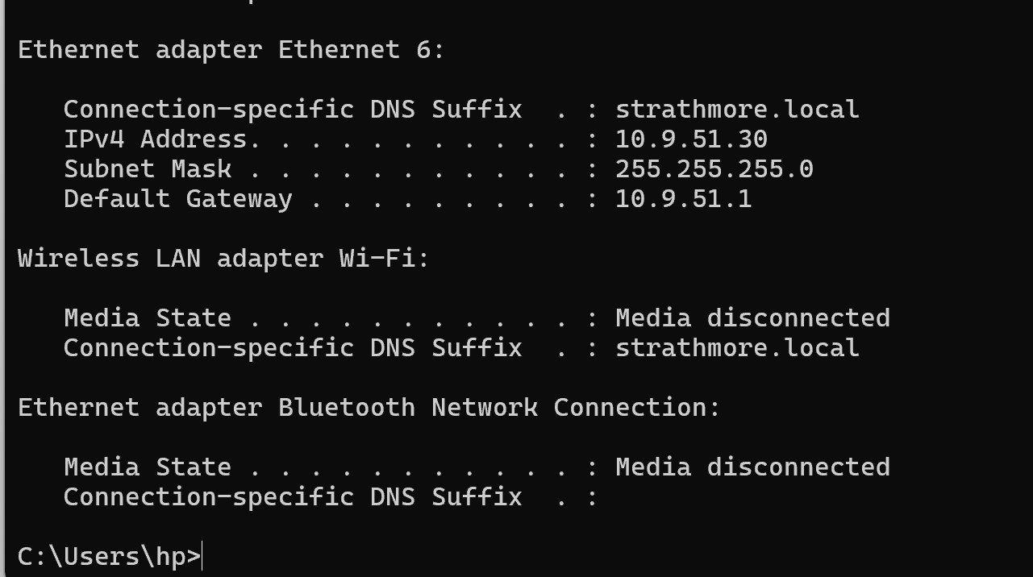

IP Fragmentation using nmap -f 10.9.51.30 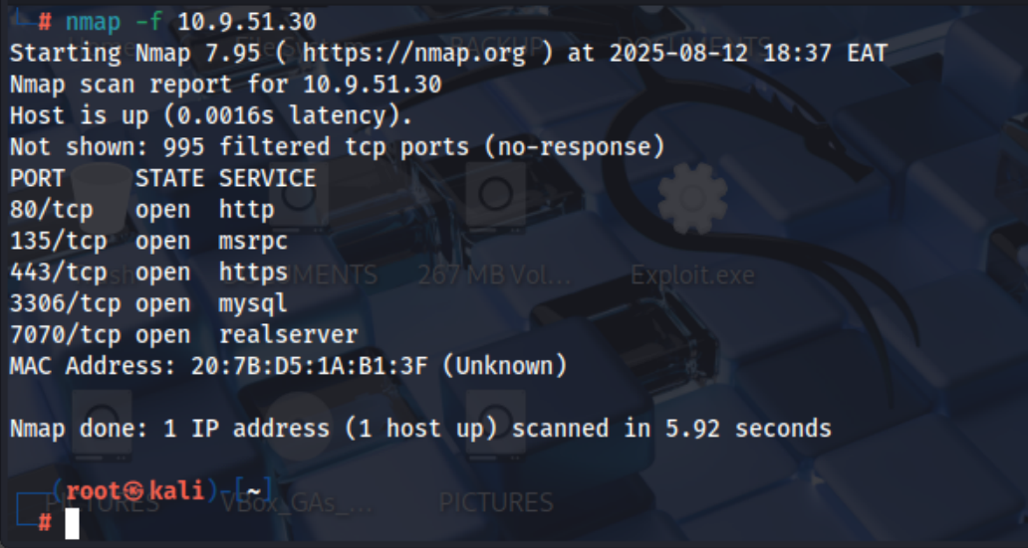

Performing Maximum Transmission Unit. 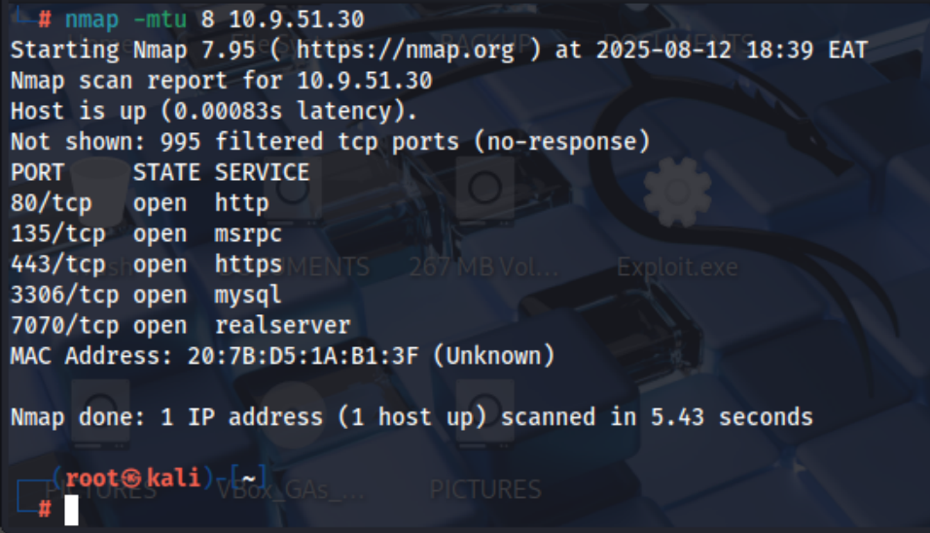

Decoying IP Addresses 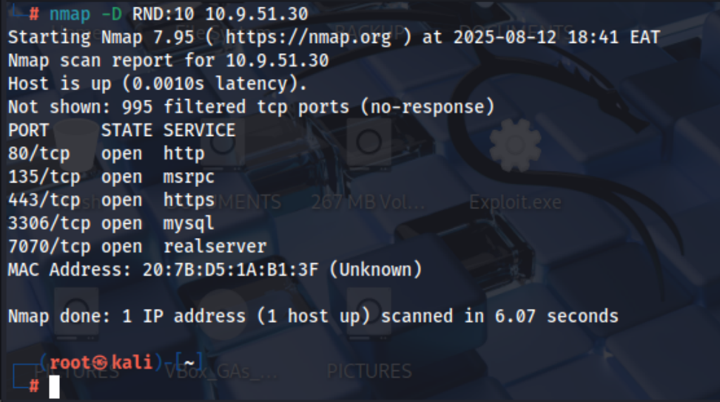

Windows Firewall Log: Decoyed IP Address. 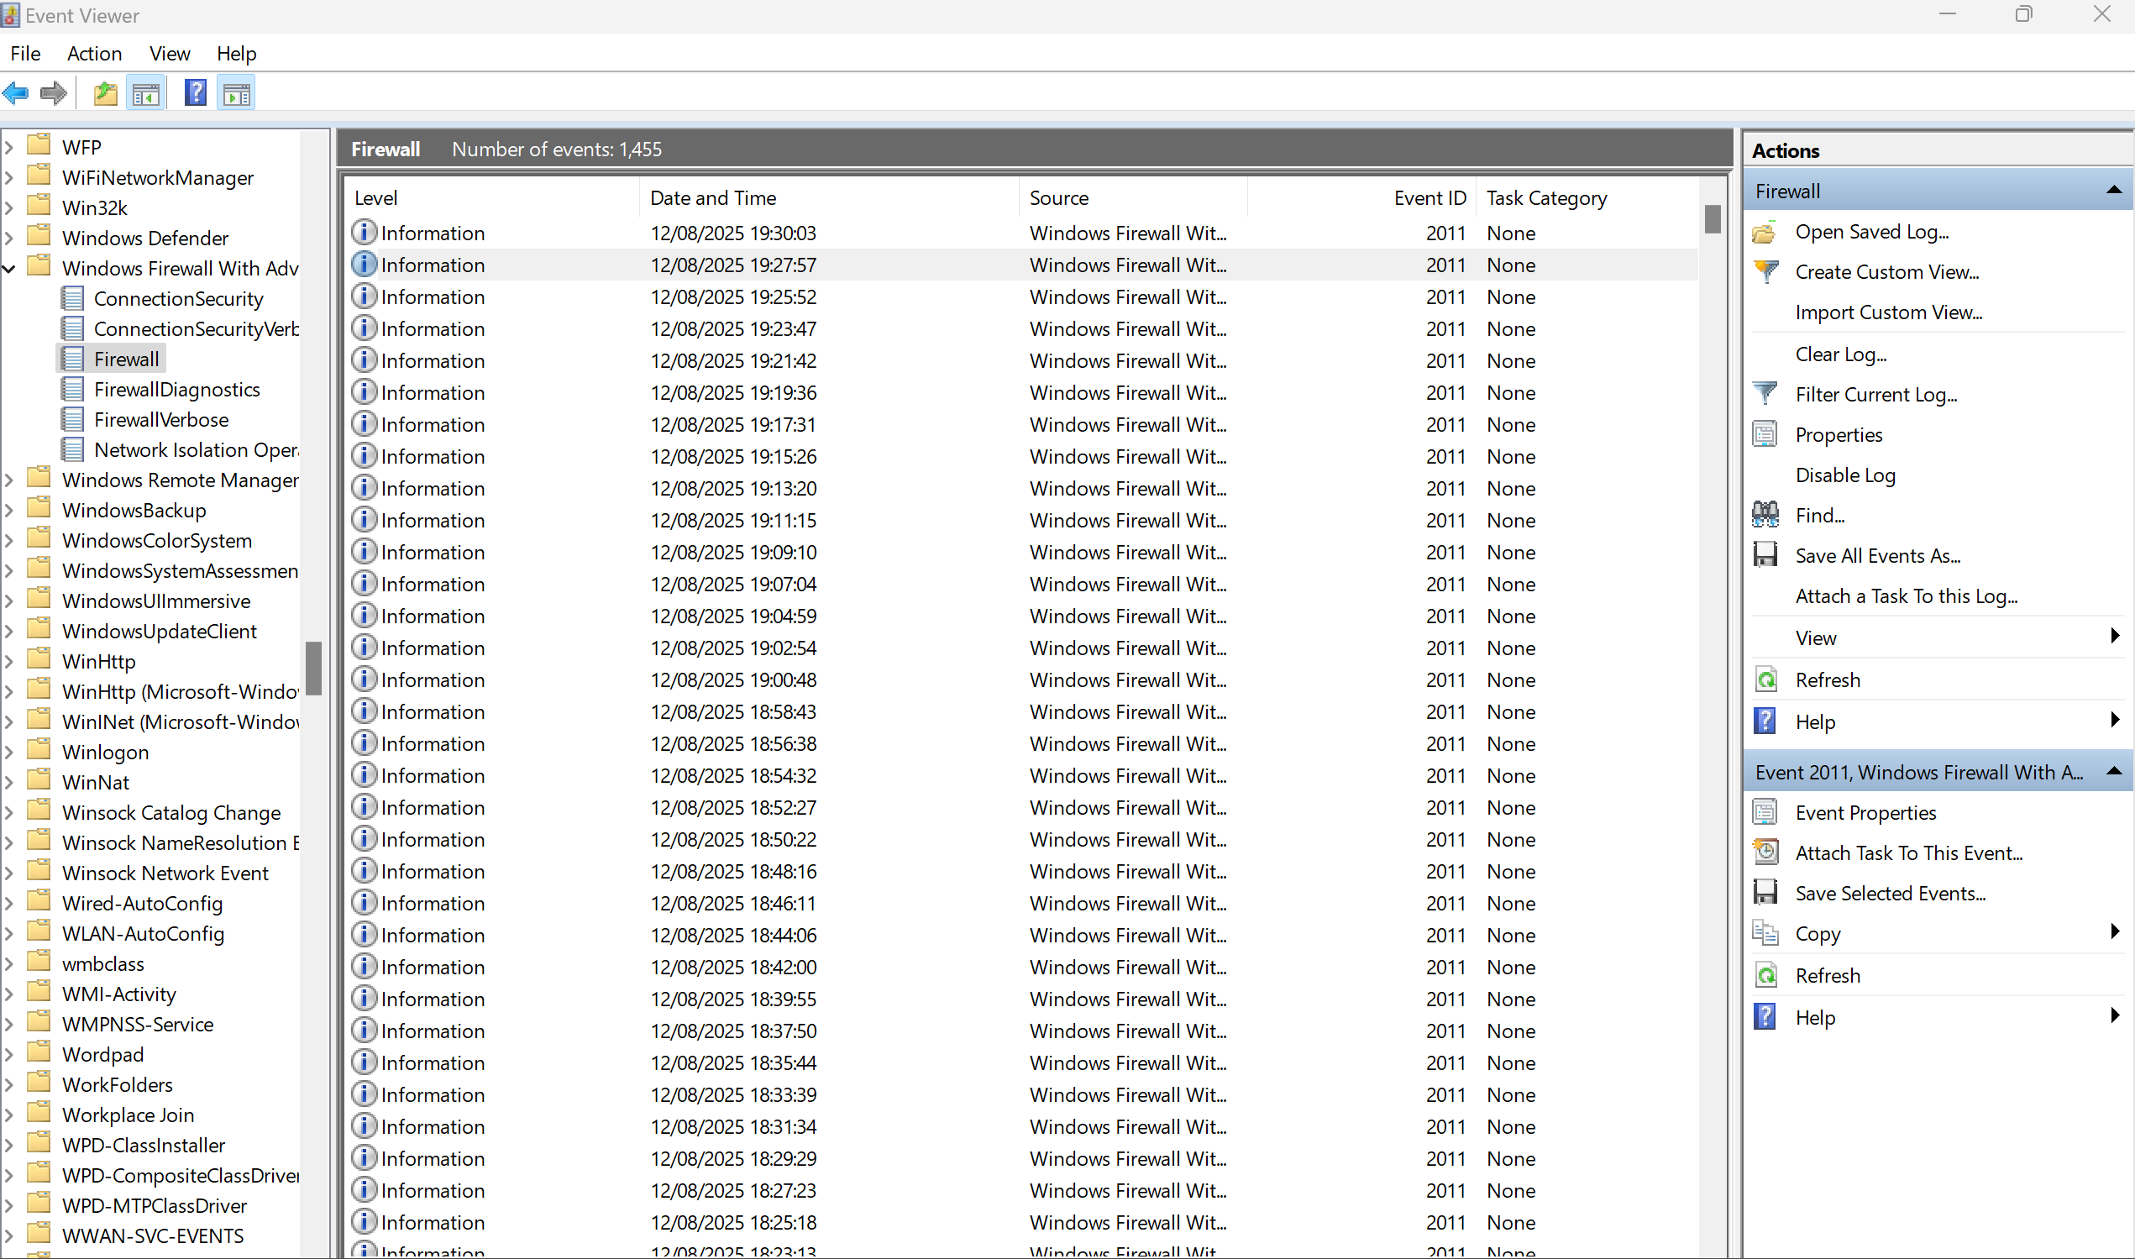

Wireshark: Decoyed IP Address. 